File Organization Techniques

DHIVYA SHREE K

230701079

Single-Level Directory Structure

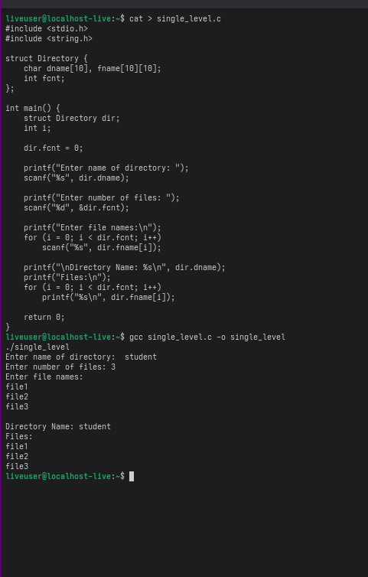

Two-Level Directory Structure

